Step 1
The Respiratory system
The respiratory system is made of a system of organs that helps the body with breathing. Breathing as a process includes bringing in oxygen to the lungs and moving it throughout the whole body. Breathing out includes taking out carbon dioxide from the blood through the lungs and releasing it into the air. To help the body with breathing, various organs like lungs, blood vessels, and airways have to function together in supplying oxygen to various body parts as well as cleaning the waste gases from the body. Although the process only includes taking air in and out of the human body, there are major processes that influence and allow breathing to occur. The brain plays a role in influencing respiration based on the levels of carbon dioxide in the body and also determines the depth of breathing. The signal sent from the brain allows the diaphragm muscles to contract as they move downwards while the ribs move upward. These movements create space in the lungs and chest. Air moves through airways like the nose or the mouth to the trachea. The air from the trachea, the air moves to the bronchi which branch into air sacs. From the air sacs, oxygen is absorbed into the blood capillaries. Carbon dioxide is released from the blood to enter the lungs through the capillaries. The diaphragm relaxes moving upwards while the ribs move downward. This decreases the amount of space in the chest cavity. This makes the lungs squeeze as they push the waste gases out through the bronchi, the trachea, and comes out through the nose or the mouth.
Relevance of the system to the body
Breathing as a process has great significance to the whole body by helping in various body processes. Breathing allows the absorption of oxygen to the body which allows body organs and muscles located in different parts of the body to function. The are other functions that the respiratory system plays in the body other than just breathing in oxygen and breathing out carbon dioxide. Breathing helps with talking and smell. One can easily smell as air is drawn through the nose. The air drawn through the mouth is also warmed also moisturized to match the temperature and the humidity in the body. The air is also purified as it enters the airways to prevent any dust or harmful substances from reaching the lungs. This also helps in preventing any irritants from getting into the body system. The lungs also help with the excretion process by removing harmful substances like carbon dioxide from the blood vessels and taking it out of the body through the mouth and the nose. The oxygen absorbed into the blood on the other hand helps the muscles and other tissues of the body with their functions. Oxygen is essential in processes like brain function, digestion as well as body movements. Proper function of the brain and mental clarity is associated with efficient breathing. Other factors which require breathing include sleep, the functionality of the immune system as well as reducing the stress levels in the body. breathing is hence, an essential process that promotes better overall functionality of the body.

Step 2
Diagram
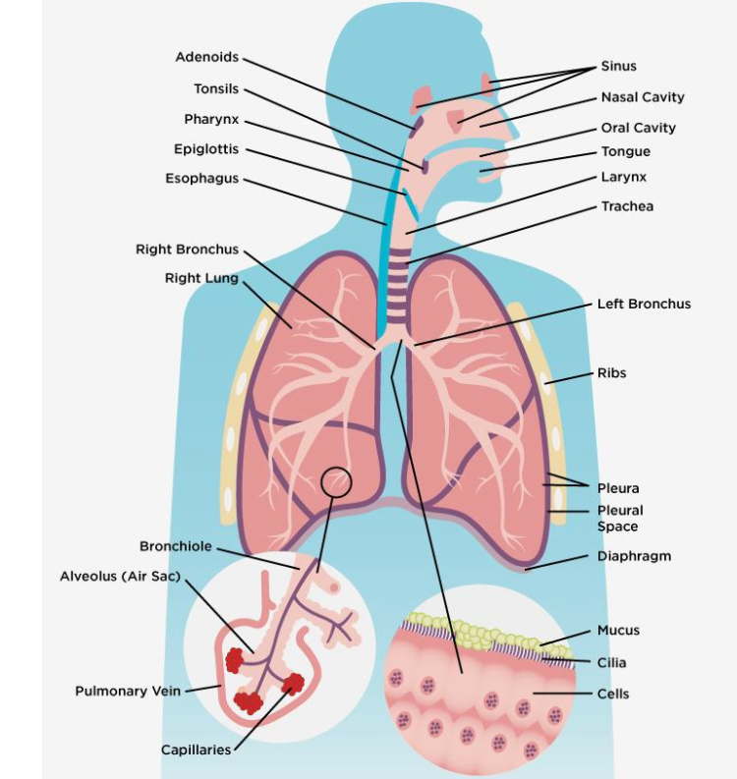

Step 3
Organs
- The nose and the nose include body openings that allow air to enter the body in the respiratory process.
- Sinuses include hollow spaces in the head bones which help in regulating the humidity and temperate of the air inhaled.
- The pharynx connects the nose and the mouth to the trachea.
- The trachea includes an air passage from the pharynx to the lungs.
- Bronchial tubes branch from the bottom of the trachea to the two lungs.
- The lungs receive the air from the bronchial tubes and provide a surface for oxygen absorption into the body system.
- The diaphragm includes muscles below the lungs responsible for pulling in air and pushing it out.
- The ribs move up and down during breathing to regulate the space in the chest cavity. They also help in protecting the lungs and heart from any external injuries.
- Bronchioles include small branches which connect the bronchial tubes to the air sacs.
- The alveoli are small air sacs found at the end of the bronchioles which provide a surface for oxygen and carbon dioxide exchange.
Step 4
Information
The respiratory system includes various organs which function to allow the exchange of oxygen and carbon dioxide in the body. All the organs involved in the respiratory process have different functions which have to function together for the functionality of the respiratory system. The mouth and the nose connect the rest of the respiratory system to the outside of the body. air moves through the sinuses to the throat which is also referred to as the pharynx. The trachea connects the pharynx to the two bronchial tubes. The bronchial tubes connect to the lungs where numerous air sacs known as the alveoli allow the exchange of oxygen and carbon dioxide. Capillaries allow blood to travel to and from the air sacs.
The respiratory system has various functions in the body. Oxygen is crucial for the functionality of body parts and muscles. The oxygen absorbed into the blood allows the functionality of various parts of the body as well as other body systems. The muscles and the brain depend on oxygen for proper functionality. Efficient breathing can promote better brain functionality which is important for the coordination of numerous body processes like movements, response, or rest. The immune system also functions efficiently in the removal of waste like carbon dioxide from the body. Breathing in and out also helps in smelling or talking as air is allowed in and out of the body.
The respiratory system allows breathing in of oxygen (inhalation) and breathing out of carbon dioxide (exhalation) from the body. Breathing is a complex process where different organs have to function together allowing air in and out of the body. Breathing starts with the contraction and downward movement of the diaphragm. The ribs move upwards and outwards increasing the space in the lungs. Air is absorbed from to the lungs through the airway openings including the mouth and the nose. The sinuses help in cleaning the air as well as regulating its humidity and temperature matching it with the rest of the body. Air travels through the hollow tubes to the air sacs where oxygen is absorbed into the blood through the blood capillaries. Carbon dioxide also travels from the blood to the lungs where it is removed through breathing out.
Respiratory system disorders
Asthma is one of the main disorders and diseases which affect the respiratory system. Asthma is characterized by inflammation of the airways which can make one experience shortness of breath. The airways may also spasm as a result of asthma and a wheezing sound is heard during breathing. Asthma is mainly caused by allergies or pollution. Acute bronchitis also affects the respiratory system. It includes inflammation of the bronchial tubes caused by a contagious or sudden viral infection. Cystic fibrosis is also an infection that affects the ability of the lungs to clear out mucus. This can influence numerous lung infections. Emphysema is a disorder that includes the damage of air sacs found on the lungs. This makes absorption of air breathed in difficult leaving it trapped in the lungs. Chronic bronchitis includes a long-term inflammation of the bronchial tubes which is mostly caused by pollution like smoking. It increases the risk of shortness of breath.
Disorder treatment
Various medications are used in controlling asthma and its effects. Long-term control includes the use of medications such as corticosteroids which can be inhaled. The medications help in preventing and reducing inflammations to reduce possible shortness of breath. Acute bronchitis can be treated by observing various preventive measures. People suffering from the disorder are advised to drink a lot of fluids but regulate their caffeine and alcohol intake. Resting and taking pain relievers can also help with the disease. Chronic bronchitis also requires preventive measures to deal with it like avoiding smoking, avoiding conditions that may cause passive smoking as well as taking medications that help with clearing mucus. Emphysema has a variety of treatments. These include vaccinations as well as taking bronchodilator medications. Oxygen therapy is also useful in treatment while severe cases may require lung surgery or transplant. Cystic fibrosis is treated using various antibiotics which help in making the mucus in the lungs thinner while others help in broadening the airways to reduce inflammation.
Step 5
List of disorders
Asthma
Acute bronchitis
Emphysema
Chronic bronchitis
Cystic Fibrosis
Step 6
Useful sources
Books
Ionescu, C. M. (2013). The human respiratory system: an analysis of the interplay between anatomy, structure, breathing, and fractal dynamics. Springer Science & Business Media.
Links
https://my.clevelandclinic.org/health/articles/21205-respiratory-system.
https://www.webmd.com/lung/lung-diseases-overview.
https://www.mayoclinic.org/departments-centers/pulmonary-medicine/sections/conditions-treated/orc-20397850.

